ZH,
REPORT OF JOINT INVESTIGATION VISIT (JIV) BY NOSDRA, RIVERS STATE MINISTRY OF ENVIRONMENT, HEIRS ENERGIES AND COMMUNITY MEMBERS TO 8’’ NKALI – IMO RIVER AT UMUOKECHI, ETCHE LGA, RIVERS STATE.
Please find below highlights of JIV to the above location.
COMPANY ADDRESS: Heirs Energies LTD, 71B Elelenwo Street, New GRA, Port Harcourt, Rivers State.
- LOCATION/SITE ADDRESS: 8’’ NKALI – IMO RIVER AT UMUOKECHI COMMUNITY, ETCHE LGA, RIVERS STATE.
- GEOREFERENCE COORDINATES/INCIDENT NUMBER:
N04 ⁰59’2.98’’, E007 ⁰07’ 31.16’’/ IN - 0663
- DATE OF INCIDENT: 12/01/2024.
- DATE OF REPORT: 12/01/2024.
- INSPECTION DATE AND TIME: 12/01/2024 AT 1357HRS
- INSPECTION TEAM:
- NOSDRA APEH, MALACHY I.
- RSMENV ATTENG, CLAUDE C.
- SITE CONTACTS:
- NPDC AYATSE, TERRY
- COMMUNITY REP ISAIAH CHIDI
- PURPOSE OF INSPECTION/ INVESTIGATION: Joint Investigation Visit (Event Response).
- COMPLIANCE HISTORY: The site complies with the Agency’s law and regulations and HEIRS ENERGIES responded appropriately.
- IMPACTED AREA: 264m²
- QUANTITY SPILLED: 40 Barrels
- QUANTITY RECOVERED; 38 Barrels
- OPENING CONFERENCE: After the initial welcome formalities, a tool-box/safety briefing coordinated by Mr Ayatse Terry (HEIRS ENERGIES Team Lead) was carried-out. Safety procedures required for the site work was explained to the JIT. The team members were also briefed about the oil spill incident.
10. WALK THROUGH INSPECTION
During the walk-through inspection of the incident site, the following were observed:
- The Joint Investigation Team (JIT) on arrival observed a long trench along the company’s Right of Way.
- A section of the trench was found to be filled to half with Crude Oil suspected to have spilled from the facility.
- 5mm drilled hole was found on the facility at 4 O’clock position which was the sources of spill.
- At the time of JIV crude oil was still spilling from the vandalized section of the facility.
- The incident was as a result of Third-party interference (theft).
- Photographs of the incident point was taken during the JIV
- The JIV was concluded successfully.
- CLOSING CONFERENCE: At the end of the inspection, stakeholders signed off the JIV documents before departure from the site.
- COMPLIANCE CONCERN:
- HEIRS ENERGIES has poor response equipment to oil spill incident
- PHOTOGRAPHS:

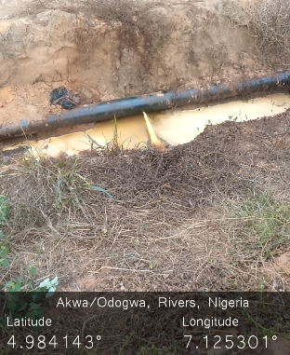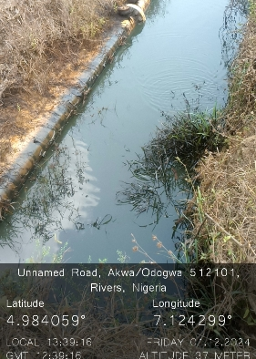
Figure 1&2: The 5mm Drilled Hole at 4 O’clock position and the impacted area.

17. RECOMMENDATION
It is recommended that:
- The company should increase surveillance around their facility to prevent similar incident in future.

APEH, MALACHY I.
PES.

